LAB EXPERIMENT RECORD
Set 20: Stock Analysis

Department | AIML
Course Code / Course Name | DSA0601 / Data Handling and Visualization
Experiment | Data Visualization using R
Name | G. GANGA CHANDRIKA
Register Number | 1925260144
Date | 15 October 2026
Day | Thursday

Aim
To visualize stock prices of three companies using a line chart, a bar chart of daily percentage change and a data table, and to combine them into a single dashboard using R (ggplot2 and gridExtra).
Dataset: Stock Prices
Date | Stock A | Stock B | Stock C
2023-01-01 | 100 | 150 | 120
2023-01-02 | 105 | 152 | 118
2023-01-03 | 110 | 148 | 122

PROGRAM 1: Line Chart of Stock Prices
Create a line chart to visualize the stock prices of three companies (Stock A, Stock B and Stock C) over the given period. Label the axes and title the chart.
# Dataset
stock_data <- data.frame(
Date = as.Date(c("2023-01-01", "2023-01-02", "2023-01-03")),
Stock_A = c(100, 105, 110),
Stock_B = c(150, 152, 148),
Stock_C = c(120, 118, 122)
)
print(stock_data)
library(ggplot2)
# Convert to long format
stock_long <- data.frame(
Date = rep(stock_data$Date, 3),
Stock = rep(c("Stock A", "Stock B", "Stock C"), each = 3),
Price = c(stock_data$Stock_A,
stock_data$Stock_B,
stock_data$Stock_C)
)
# Line Chart
ggplot(stock_long, aes(x = Date, y = Price,
color = Stock, group = Stock)) +
geom_line(linewidth = 1) +
geom_point(size = 3) +
labs(title = "Stock Prices Over Time",
x = "Date",
y = "Stock Price",
color = "Company") +
theme_minimal()

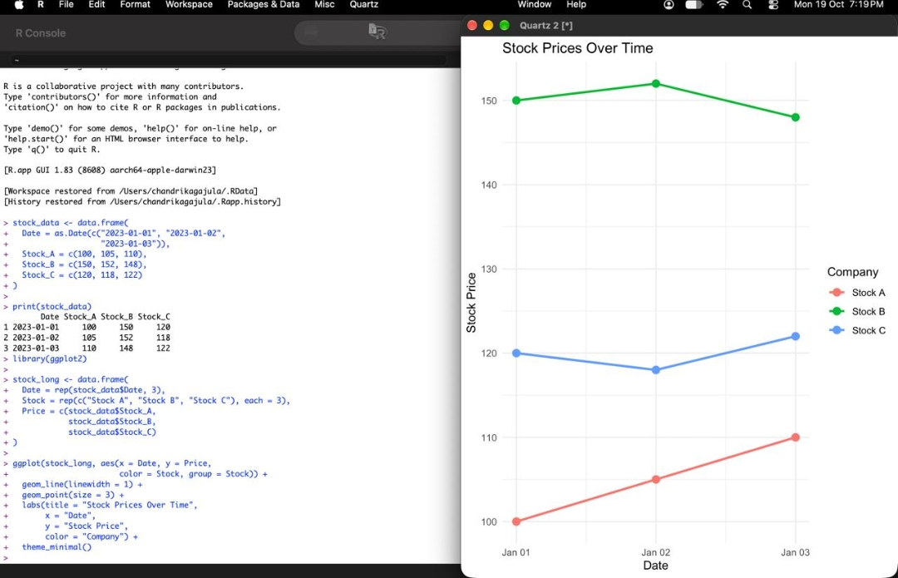
Output 1: Stock Prices Over Time Line Chart
Observation: Stock A rises steadily from 100 to 110, Stock B stays highest (148 to 152) with a small rise and fall, and Stock C remains between 118 and 122.

PROGRAM 2: Bar Chart of Daily Percentage Change in Stock A
Generate a bar chart showing the daily percentage change in the stock price of Stock A. Label the chart elements.
# Daily percentage change of Stock A
stock_data$Percentage_Change <- c(
NA,
diff(stock_data$Stock_A) /
head(stock_data$Stock_A, -1) * 100
)
change_data <- stock_data[!is.na(
stock_data$Percentage_Change), ]
# Bar Chart
ggplot(change_data,
aes(x = Date, y = Percentage_Change)) +
geom_col(fill = "steelblue") +
geom_text(aes(label = paste0(
round(Percentage_Change, 2), "%")),
vjust = -0.5) +
labs(title = "Daily Percentage Change in Stock A",
x = "Date",
y = "Percentage Change (%)") +
theme_minimal()

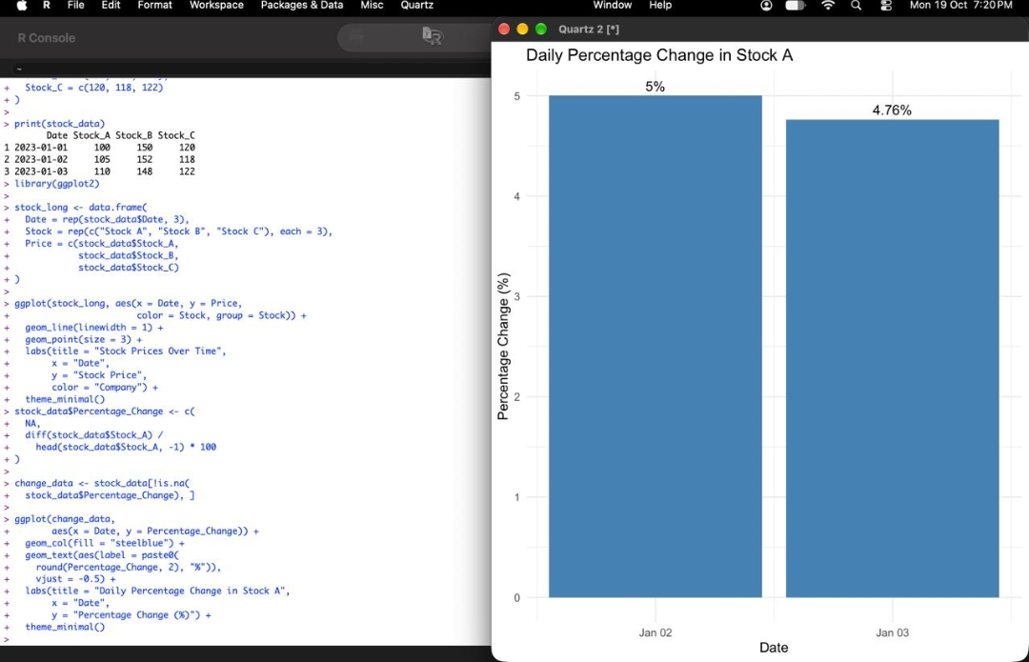
Output 2: Daily Percentage Change in Stock A
Observation: Stock A increased by 5% on 2023-01-02 (100 to 105) and by 4.76% on 2023-01-03 (105 to 110).

PROGRAM 3: Stock Price Table
Build a table to display the stock price data for each company over the given period. Label the table elements.
# Create the stock price dataset
stock_data <- data.frame(
Date = c("2023-01-01", "2023-01-02", "2023-01-03"),
Stock_A = c(100, 105, 110),
Stock_B = c(150, 152, 148),
Stock_C = c(120, 118, 122)
)
# Display the stock price table
print(stock_data)

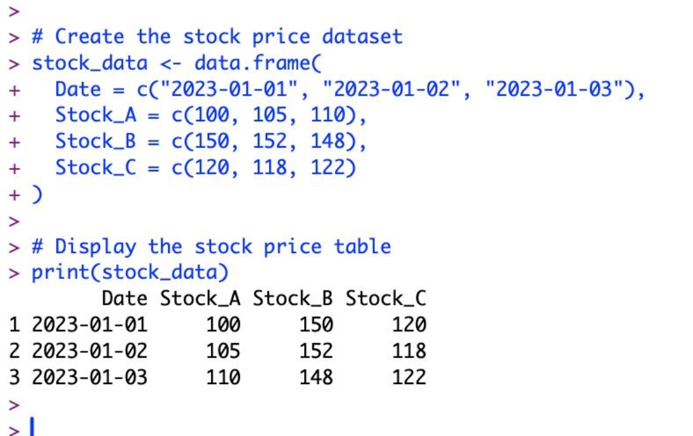
Output 3: Stock Price Table
Observation: The table lists the date and the price of Stock A, Stock B and Stock C for each of the three days.

PROGRAM 4: Stock Analysis Dashboard
Develop a dashboard combining the line chart, the bar chart and the table for exploring the stock prices.
library(ggplot2)
library(gridExtra)
# Line chart
p1 <- ggplot(stock_long,
aes(x = Date, y = Price,
color = Stock, group = Stock)) +
geom_line(linewidth = 1) +
geom_point(size = 3) +
labs(title = "Stock Prices",
x = "Date", y = "Price",
color = "Stock") +
theme_minimal()
# Bar chart
p2 <- ggplot(change_data,
aes(x = Date, y = Percentage_Change)) +
geom_col(fill = "steelblue") +
geom_text(aes(label = paste0(
round(Percentage_Change, 2), "%")),
vjust = -0.5) +
labs(title = "Stock A Daily Change",
x = "Date",
y = "Change (%)") +
theme_minimal()
# Stock price table
stock_table <- tableGrob(
stock_data[, c("Date", "Stock_A",
"Stock_B", "Stock_C")],
rows = NULL,
theme = ttheme_minimal()
)
# Display all three in one dashboard
grid.arrange(
p1, p2, stock_table,
ncol = 2,
top = "Stock Analysis Dashboard"
)

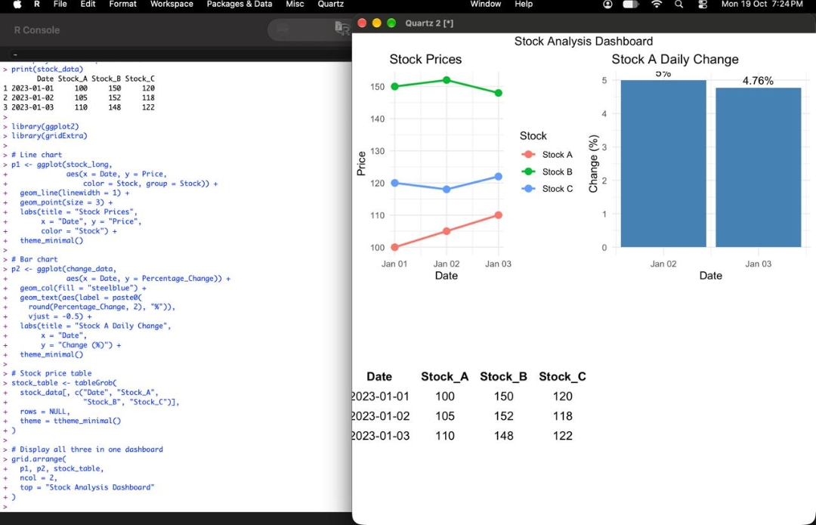
Output 4: Stock Analysis Dashboard
Observation: The dashboard shows the line chart, the Stock A percentage-change bar chart and the stock price table together in one view.

Procedure
1. Create a data frame with the Date, Stock A, Stock B and Stock C values.
2. Convert the data to long format and use ggplot() with geom_line() and geom_point() to draw the line chart; add the title and axis labels using labs().
3. Calculate the daily percentage change of Stock A using diff(), then draw the bar chart using geom_col() with percentage labels.
4. Display the stock price data as a table using print() and tableGrob().
5. Combine the line chart, bar chart and table into one dashboard using grid.arrange().
Result
The stock prices of three companies were successfully visualized using a line chart, the daily percentage change of Stock A was shown using a bar chart, and the data was displayed as a table. All three were combined into a single stock analysis dashboard.
Key R Functions Used
Function | Purpose
data.frame() | Creates the stock price dataset.
ggplot() | Creates the base plot for the charts.
geom_line() / geom_point() | Draw the lines and points of the line chart.
geom_col() / geom_text() | Draw the bars and percentage labels.
diff() | Calculates the day-to-day price difference.
tableGrob() | Creates the table to display in the dashboard.
grid.arrange() | Combines the charts and table into one dashboard.

